

**APOSTOLIC VICARIATE OF ISIOLO**

**ISIOLO COVID-19 EMERGENCY RESPONSE**

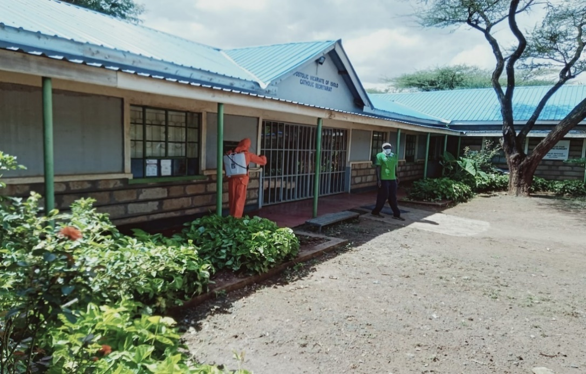

Fumigation of Apostolic Vicariate of Isiolo Secretariat

**FINAL REPORT**

**OCTOBER 2020**

1. **BACKGROUND**

The Vercelli Archdiocese funded Isiolo COVID-19 Emergency Response Project was developed in response to the COVID-19 pandemic which constitutes a key threat to the life, socio and economic wellbeing of Kenyans at large Isiolo County residents in particular. The first case of the infectious disease was reported in Kenya on 13th March, 2020. Since then the cases have been increasing and currently stand at 38,115 nationally (as at 28th September 2020). The Apostolic Vicariate of Isiolo has reported 60 cases to-date.

This final report highlights achievements made in implementation of the project by the Apostolic Vicariate of Isiolo (AVI) as it complemented efforts of the National and County Governments to combat the COVID-19 pandemic. Challenges encountered during implementation and lessons learned are also provided in this report.

1. **ACHIEVEMENTS**

**Personal Protective Equipment (PPEs):** On 14th and 15th May 2020, the Vicariate through its Health Department procured assorted Personal Protective Equipment (PPE) and other associated supplies which were distributed to 6 health facilities namely Matercare Hospital, Isiolo Catholic Dispensary, Kinna Dispensary, Merti Dispensary, Ngaremara Dispensary and Camp Garba Dispensary. The supplies were: surgical masks, respirators, disposable non-woven fabric protective overalls, non-powder gloves, disposable gowns, pulse oximeter machines, chlorine powder, theater/gum boots, face shields, patient monitor and oxygen concentrators. In addition, 26 drums/ tanks and Back-nuts, non-contact infrared forehead thermometers, face shields, disinfectants, alcohol hand based sanitizers and 1,000 litres of liquid soap were procured and subsequently distributed to the health facilities, Bishop Albino Mensa Pastoral Centre, Bishop’s Residence, Apostolic Vicariate of Isiolo Secretariat and 11 Parishes namely St. Eusebius Cathedral, Kambi ya Juu, Camp Garba, Ngaremara, Merti, Kiwanjani, Garbatulla, Kinna, Kipsing, Oldonyiro and Leparua.

**Fumigation:** Between May and August 2020, 5 facilities were fumigated namely Bishop’s residence, Apostolic Vicariate of Isiolo Secretariat, St. Eusebius Cathedral Parish and Priest’s residence and Radio Shahidi Office. The exercise is ongoing.

**COVID-19 sensitization**: Between 12th May and 23rd July 2020, COVID-19 sensitization in was conducted in various Parishes namely St Eusebius Cathedral, Camp Garba, Kambi ya Juu and Kiwanjani. The sensitization targeted Parish Staff, Small Christian Community representatives, Caretakers, People with Disabilities (PDWs) and Orphaned Vulnerable Children (OVCs). The sensitization was facilitated by Staff from AVI Matercare Hospital (Sr. Mercy CDI Health Coordinator/Administrator, AVI Matercare Hospital and Eric Kirimi, Nurse).

The facilitators focused on the following:

1. *Brief overview of COVID-19*- Coronaviruses are a large family of viruses that usually cause mild to moderate upper-respiratory tract illnesses, like the common cold. COVID-19 Infectious respiratory disease caused by a new strain of coronavirus.
2. *Clinical symptoms-* Include fever, dry cough, tiredness, aches and pains, sore throat, diarrhea, headache, loss of taste or smell, difficulty breathing or shortness of breath.
3. *Transmission/spread -* Primarily through droplets of saliva or discharge from the nose when an infected person coughs or sneezes, contact with contaminated surfaces or articles with coronavirus.
4. *Protective measures*- include social distancing (maintain at least 1 meter (3 feet) distance between yourself and others); avoid going to crowded places/ stay at home if no compelling reason for one to go to a public place; follow good respiratory hygiene- covering your mouth and nose with your bent elbow or tissue when you cough or sneeze. Then dispose of the used tissue immediately and wash your hands; covering the mouth and nose with a protective mask, avoid touching eyes, nose and mouth; regularly and thoroughly clean your hands with an alcohol-based hand rub or wash them with soap and water; stay home and self-isolate even with minor symptoms such as cough, headache, mild fever, until you recover. If you need to leave your house, wear a mask to avoid infecting others; avoid shaking hands

The facilitators used various methods during the sensitization including mini lectures, question/answer and demonstration.

In addition, the Vicariate undertook mass public sensitization using car mounted public address system. The Vicariate team, area chiefs and community health Unit volunteers managed to put across the right information (facts) on the disease including but not limited to; What COVID-19 is, how its spread, its Signs and symptoms, myths and misconceptions about COVID-19 and how one can protect self and others. Sensitization targeting Community Health Volunteers in Kipsing, Oldonyiro, Merti and Garbatulla Parishes within the Diocese was also undertaken. Subsequently, the CHVs conducted door to door sensitization that targeted households in Kipsing, Oldonyiro, Merti and Garbatulla Parishes.

Information, education and communication (IEC) materials with Covid-19 messages (posters and stickers) were printed and subsequently distributed to the 11 parishes. The bulk SMS and social platforms that traversed the whole of Isiolo county were also used to disseminate messages.

Sensitization on Covid-19 was also carried out through local radio station (Radio Shahidi) that targeted St Eusebius, Kiwanjani, Kinna, Kambi ya Juu, Camp Garba, Ngaremara where the church radio airwaves reaches).

The Vicariate distributed of food and non-food items comprised of rice, salt, beans, maize meal, cooking oil, soap to 5 homes catering for the elderly, PWDs and OVC namely Divine Providence, Alakara, Jesus, Mary & Joseph, Hope Child and New Life Charity Home.

**Mask distribution**: 3,790 reusable masks were made and subsequently distributed to AVI Secretariat Staff, Parishes, Bishop Mensa Pastoral Centre, local communities, health facilities and education institutions within the Apostolic Vicariate of Isiolo. In addition, surgical masks were also procured and distributed to the Vicariate’s health facilities.

1. **CHALLENGES**
2. Some participants for CDI Staff Covid-19 sensitization did not turn up for the activity due to the current harsh socio-economic situation. Some of the staff work in CDI education institutions that are categorized as private and thus solely rely on fees payment for income which is not forthcoming due to closure of schools to curb spread of Covid-19. They had to go out to search alternative means of getting a livelihood.
3. Inability to address emerging pressing needs of the communities that have borne the brunt of Covid-19 pandemic notably food. During the follow up and monitoring visits, communities repeatedly requested for food support which is not factored in the project. The Caritas Isiolo team observed that due to movement restrictions coupled with market closures in effort to control spread of Covid-19, basic food commodity prices have increased. For instance, in Oldonyiro, the prices of beans and green grams (1kg) that normally sell at Ksh. 100 and 70 have increased to Ksh.120 and 100 respectively. The situation in Oldonyiro is exacerbated inadequate pasture for caused by destruction by desert locusts. Livestock which constitutes main source of food and income for majority of the households. Though the locusts were eventually eradicated, the damage caused is still being felt in the area.
4. **LESSONS LEARNED**
5. Sensitization of staff and grassroots church leadership at their settings is effective in addressing misinformation/myths which helps in reducing anxieties around the COVID-19 disease. The myths include COVID-19 “hates the sun”, it does not attack young people, can be prevented by regularly taking a few sips of warm water, does not infect those who take alcohol, it is a disease of urbanites among others. During the meetings, accurate information on the COVID-19 disease was provided by the facilitators to the satisfaction of the participants thereby dispelling the myths and misinformation surrounding it.
6. Rather than just sharing information, it is important to address misinformation to avoid increasing anxiety around the Covid-19 pandemic. Face to face sensitization helps the target audience to understand perceptions, tackle misinformation and adjust their approach accordingly. During the sensitization at St Eusebius Cathedral Parish (St Mary’s Secretarial College) targeting teaching and non-teaching staff, the audience got opportunity to ask questions on Covid-19 including misinformation and myths. The facilitator answered the questions and clarifications sought to the satisfaction of the target audience.
7. Rural areas hardly access information on an infectious disease outbreak which in effect can easily increase risk of spread among the rural communities. In this regard, it is important to provide them with the relevant knowledge via face to face communication using a language they understand. This will enhance their understanding and consequently prompt them to take protective measures and consequently prevent the spread of the disease. In this activity, residents of Leparua do not have sufficient information on COVID-19 by the virtue of its location i.e. far from Isiolo Town. In this regard, the face to face sensitization contributed to increased understanding about the disease. The participants got opportunity to ask questions which were satisfactorily answered by the facilitator. A local community leader was at hand to translate which in effect ensured that the participants understood the message conveyed.

**PHOTOS**

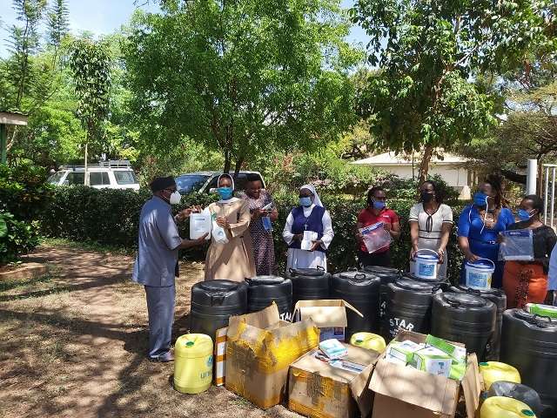

His Lordship Rt. Rev. Anthony Ireri Mukobo, Bishop Apostolic Vicariate of Isiolo having received Personal Protective Equipment and other supplies hands them over to Sr. Maria Consolata and other AVI Secretariat & Matercare Hospital Staff.

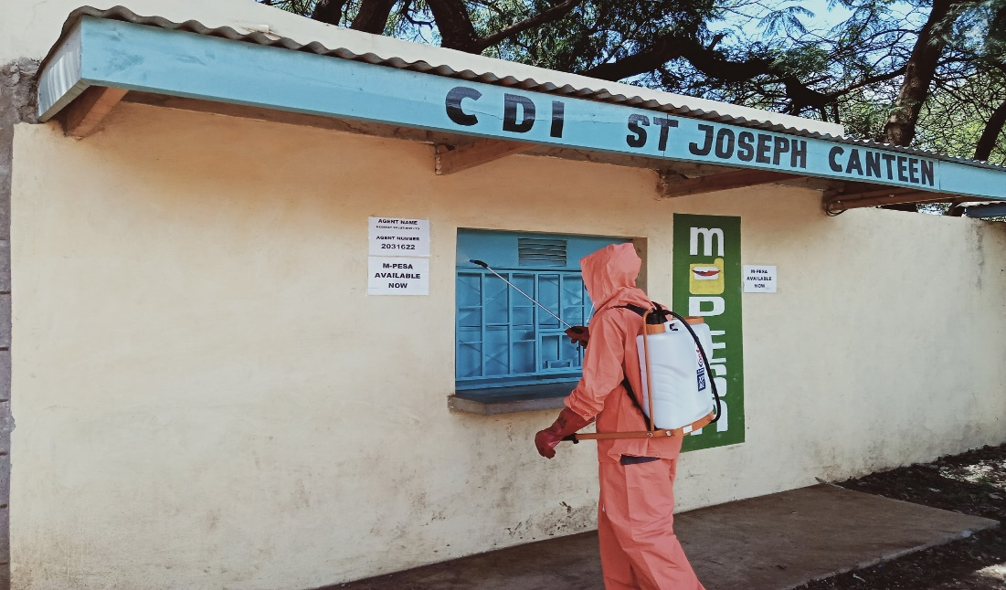

Fumigation of CDI St Joseph Canteen within St Eusebius Cathedral Grounds

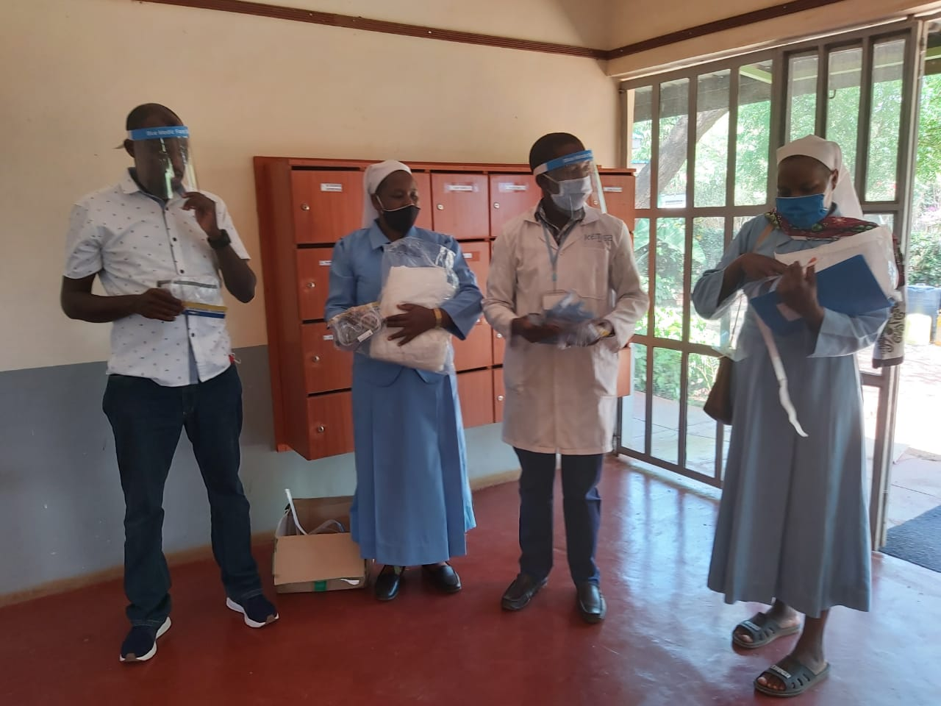

Rev. Fr. Robyn Lekorere (left), AVI Finance Administrator, Sr. Mercy CDI Health Coordinator/Administrator, AVI Matercare Hospital (2nd left), Dr. Celestine, AVI Matercare Hospital and Sr. Joselyn, AVI Accountant examine face supplied as part of PPEs.

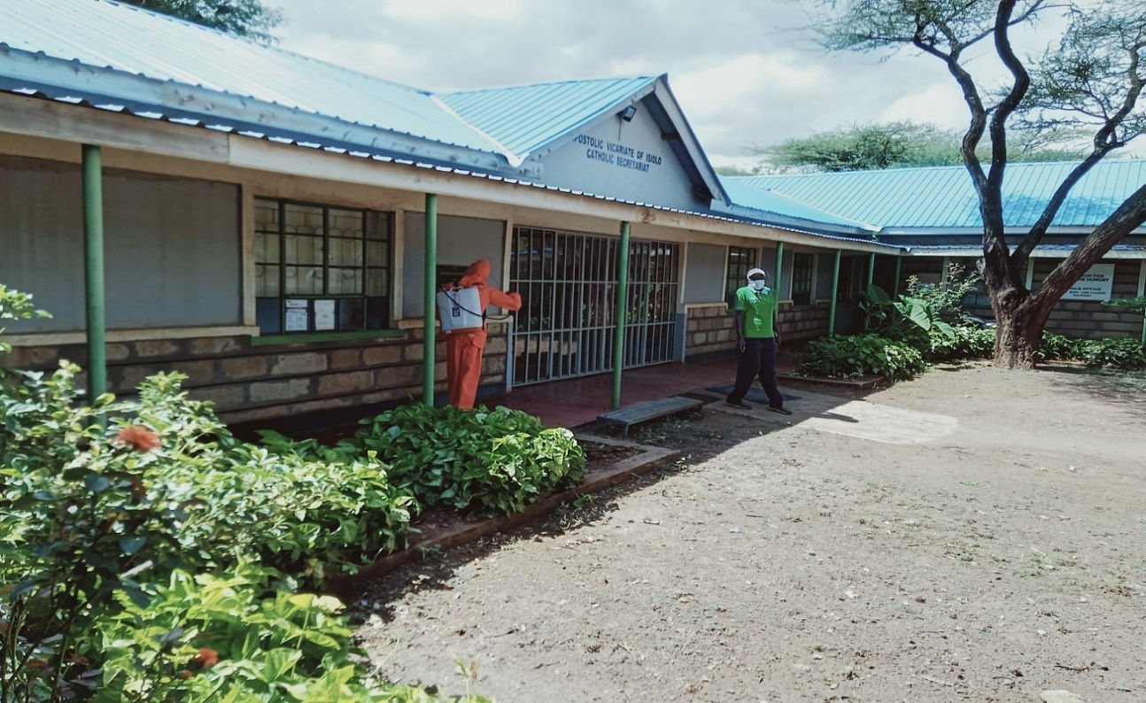

Fumigation of Apostolic Vicariate of Isiolo Secretariat

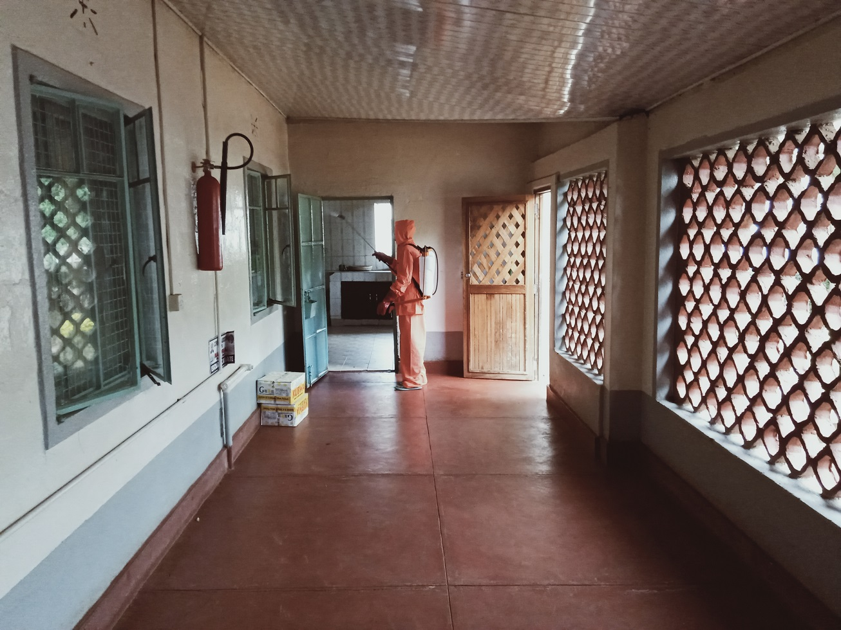

Fumigation of St Eusebius Cathedral Parish Priest’s residence

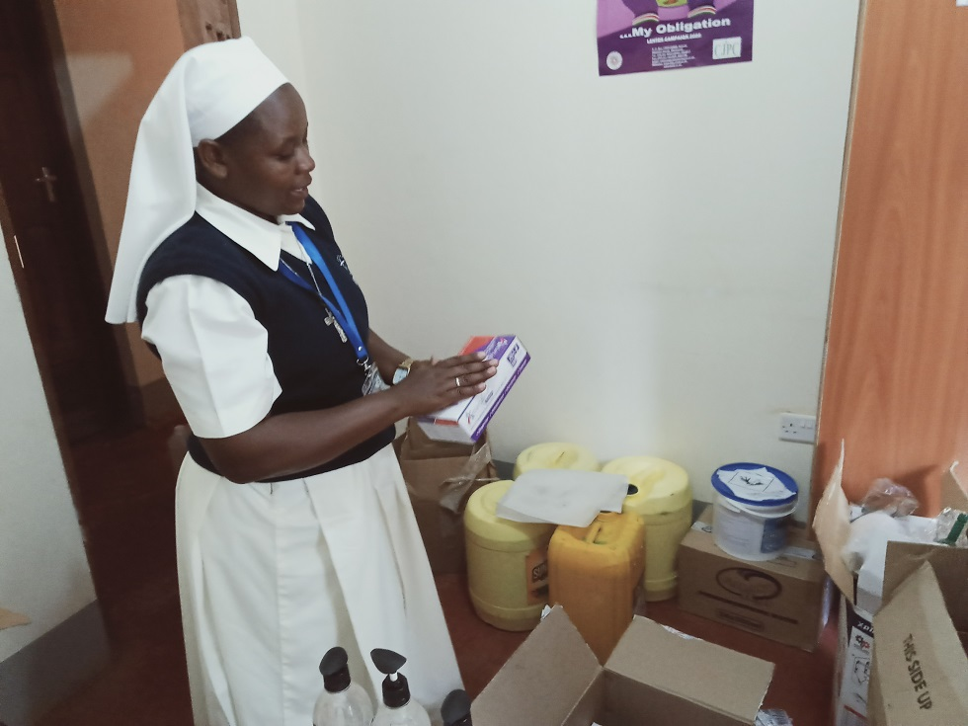

Sr. Mercy CDI Health Coordinator/Administrator, AVI Matercare Hospital holds a pair of clean gloves.

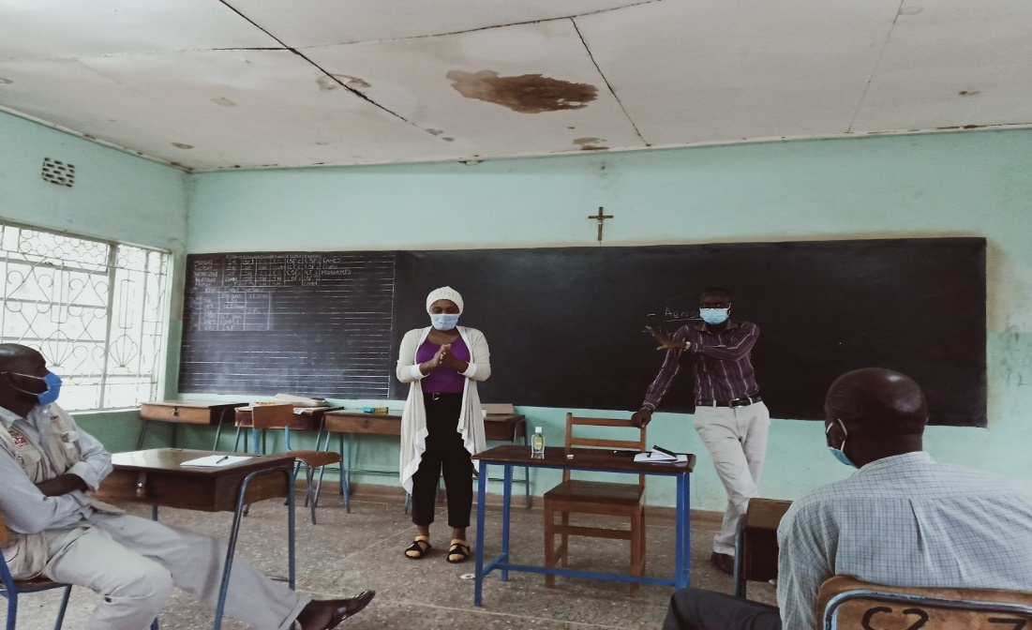

A female participant (right) makes a hand washing demonstration as the facilitator stresses a point during Covid19 sensitization at St Mary’s Secretarial College

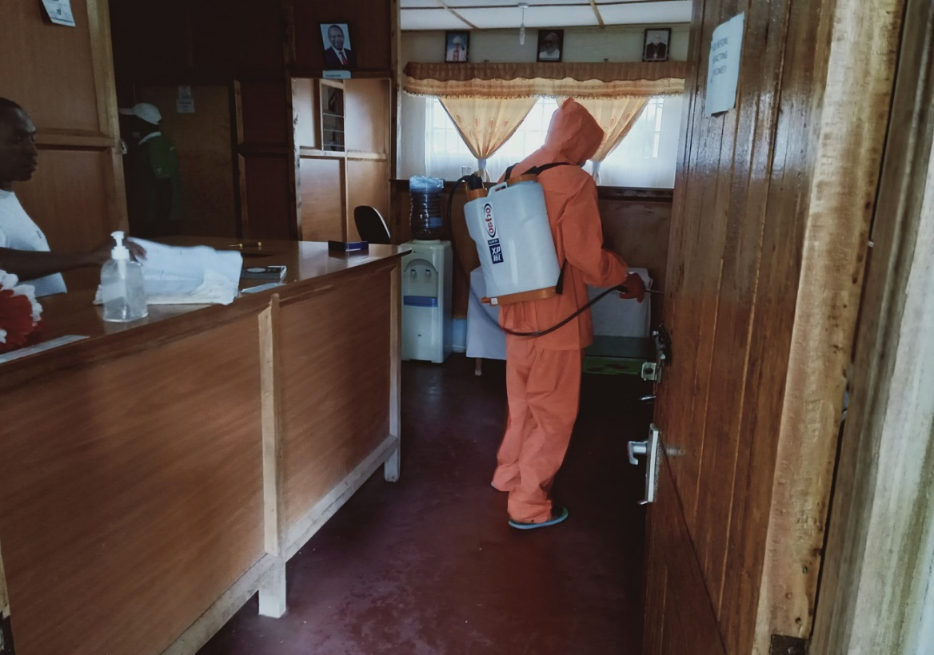

Fumigation of Radio Shahidi Office

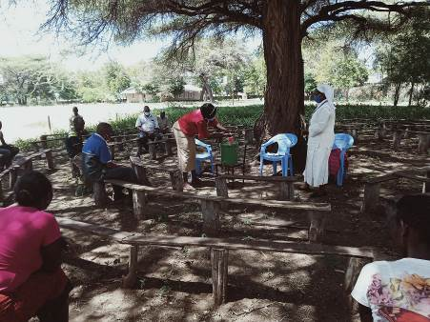

A participant washes her hands as Sr. Mercy and other participants look on during sensitization of CDI Camp Garba Parish Staff on COVID-19.

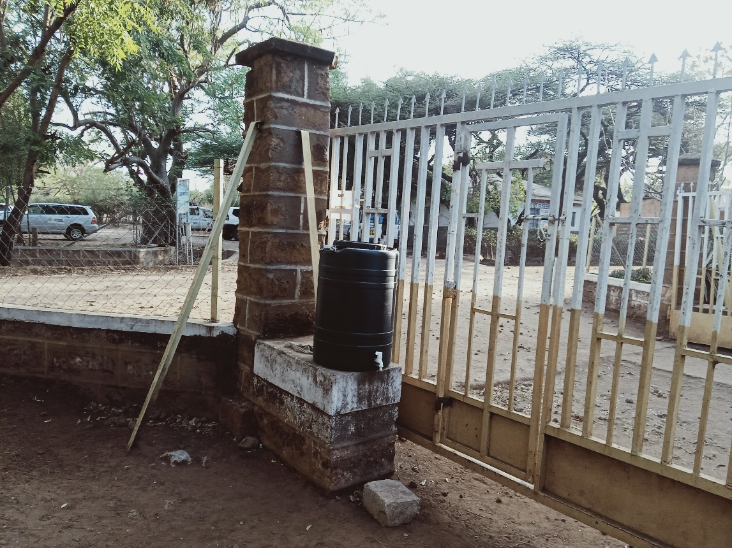

A 100 litres water tank for hand washing at St Eusebius Cathedral Parish Entrance.

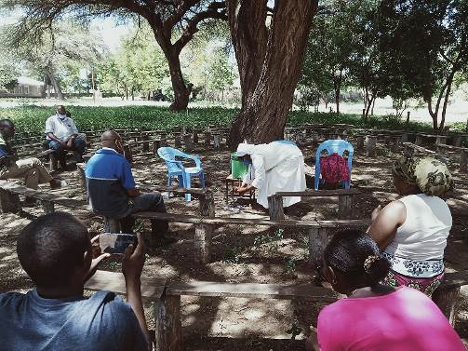

Sr. Mercy makes a demonstration on hand washing during sensitization of CDI Camp Garba Parish Staff on COVID-19.

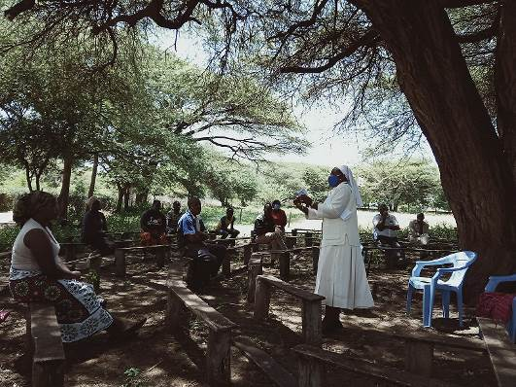

Sr. Mercy explains use of a face mask during sensitization of CDI Camp Garba Parish Staff on COVID-19.

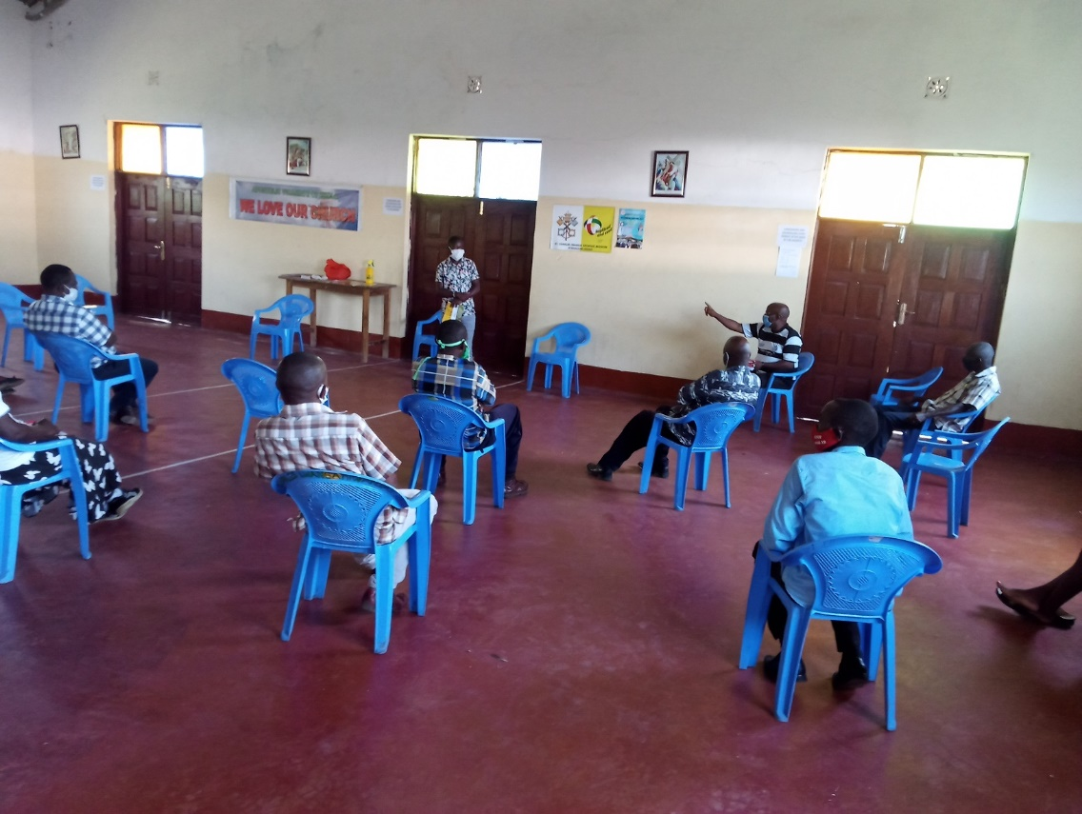

Fr. James Mathenge, CDI CJPC Coordinator makes a contribution during sensitization of CDI Kiwanjani Parish Staff on COVID-19

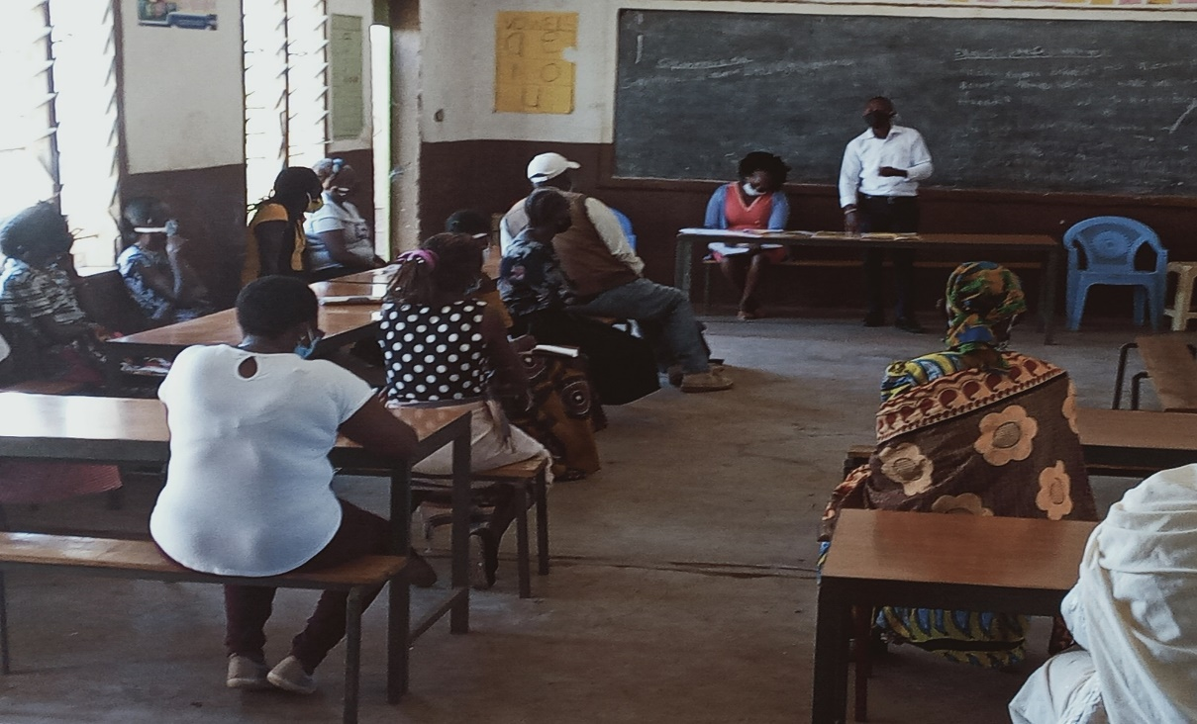

Eric Kirimi, a Nurse at AVI Matercare Hospital explains a point during sensitization of CDI Kambi Ya Juu Parish Staff & Small Christian Community Leaders on COVID-19

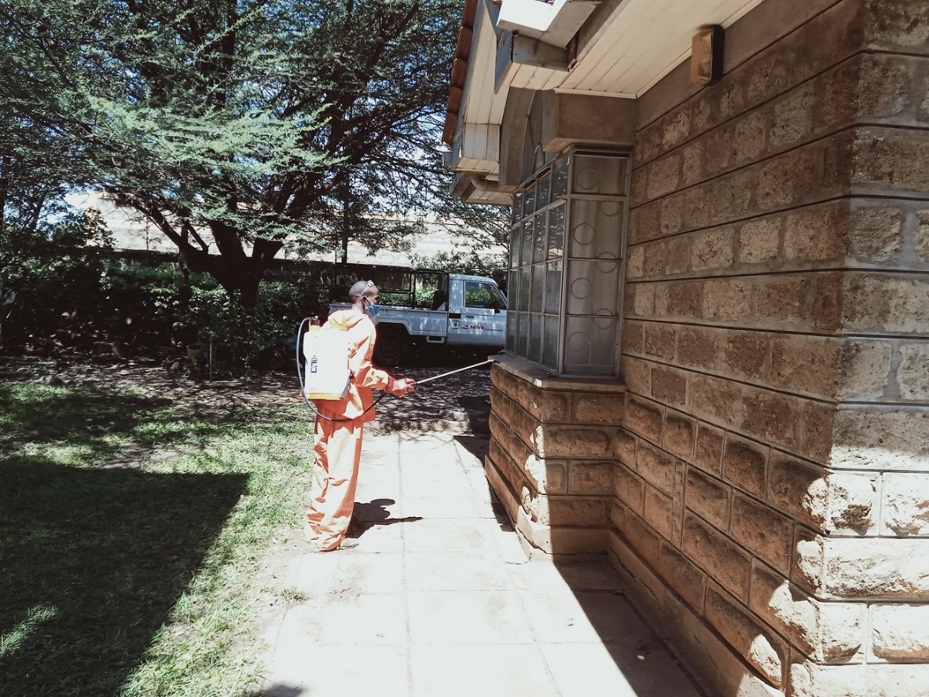

Fumigation of Bishop’s residence

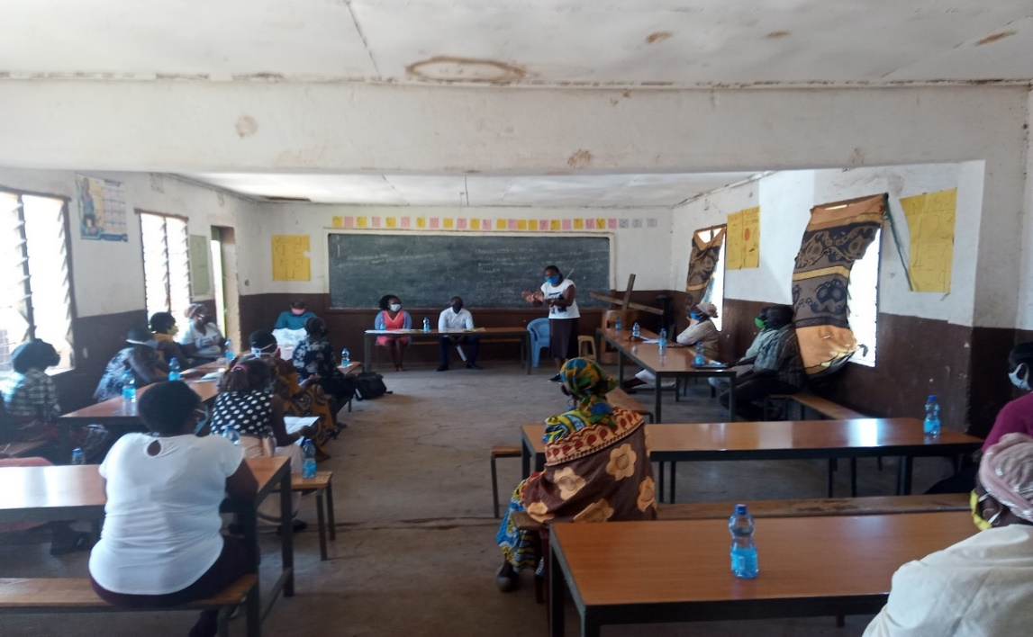

A participant demonstrates on hand washing during sensitization of CDI Kambi Ya Juu Parish Staff & Small Christian Community Leaders on COVID-19

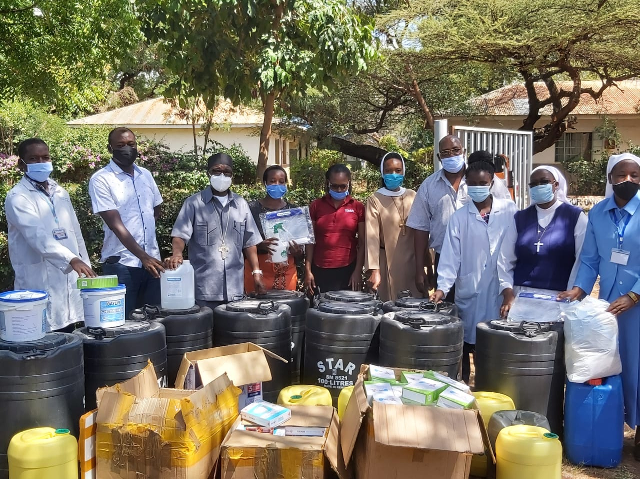

His Lordship Rt. Rev. Bishop Anthony Ireri Mukobo (3rd from left), Rev. Fr. Robyn Lekorere (2nd from left), AVI Finance Administrator and AVI Secretariat and AVI Matercare Hospital Staff pose with the Personal Protective Equipment and other supplies delivered by suppliers.

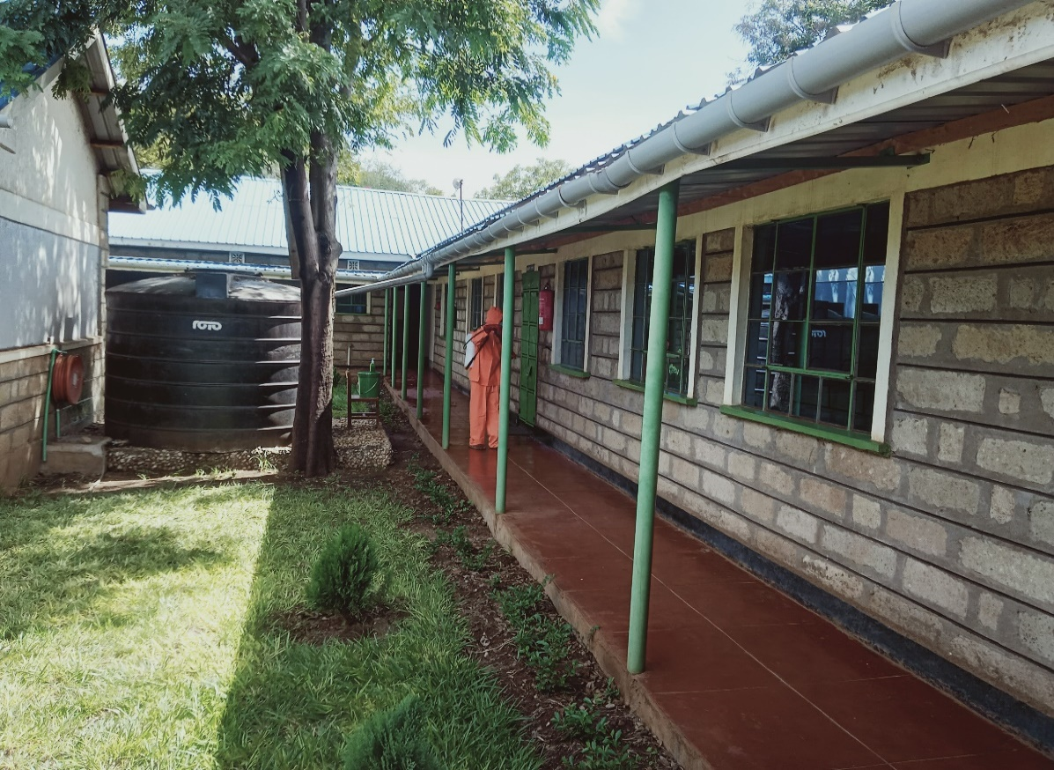

Fumigation of Apostolic Vicariate of Isiolo Secretariat

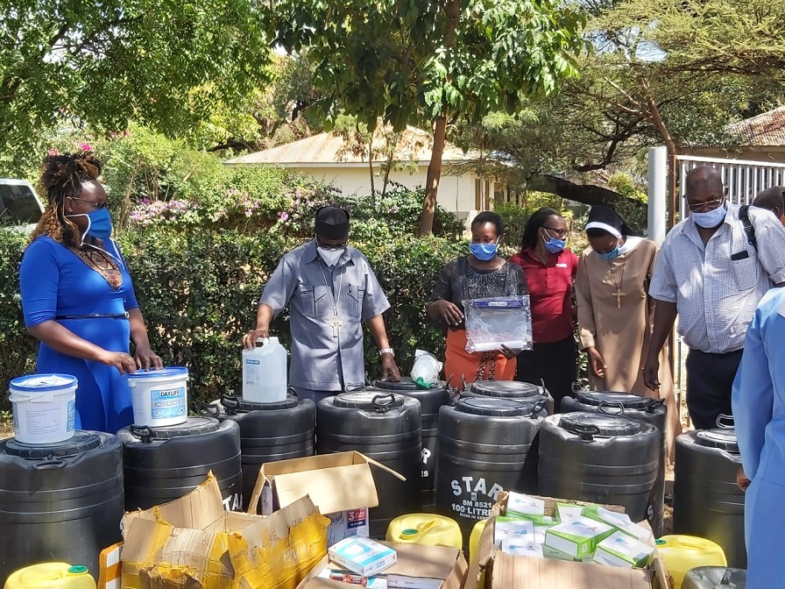

His Lordship Rt. Rev. Bishop Anthony Ireri Mukobo (2nd from left) and some of the AVI Secretariat Staff examine the Personal Protective Equipment and other supplies delivered by suppliers.

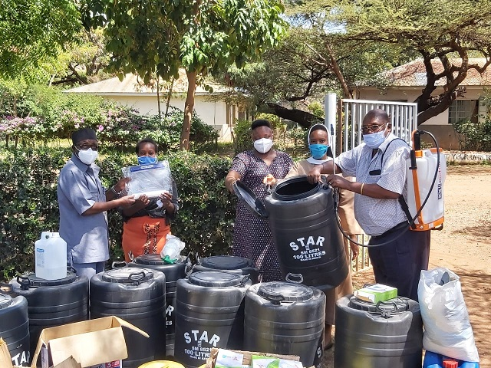

His Lordship Rt. Rev. Bishop Anthony Ireri Mukobo and AVI Secretariat Staff holding some of the Personal Protective Equipment and other supplies delivered by suppliers.

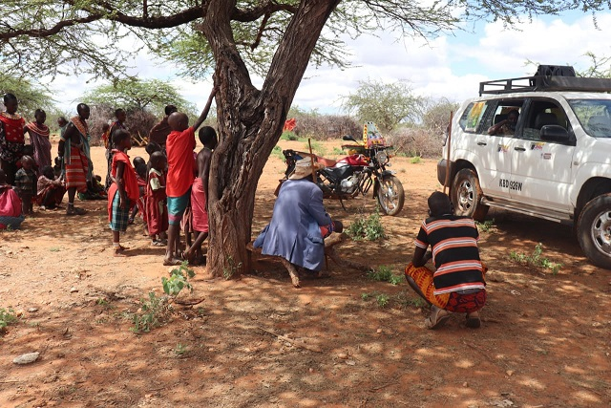

Labshereki community members in Oldonyiro listen to a COVID-19 message delivered during mass sensitization using a mobile public address system.

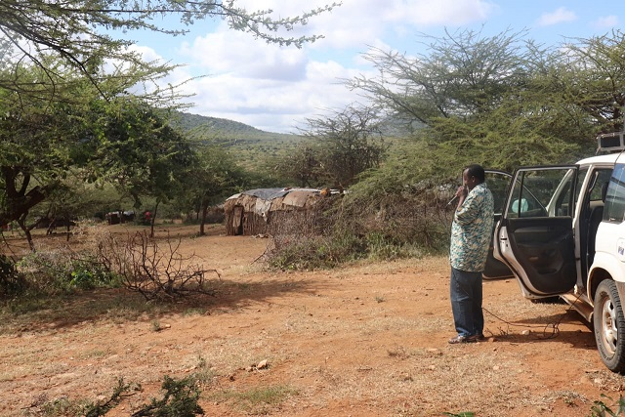

Dan Leleruk, Public Health Officer, Oldonyiro Ward delivers a COVID-19 message at Noloroy during mass sensitization using a mobile public address system.

Yours in the lord’s service

Rev Fr Robyn Lekorere

Procurator